The most recent pvops kernel 2.6.32.19 allows to enable kernel modesetting (KMS) under Xen 4.0.1-rc6 on top of Ubuntu Lucid Server and Fedora 13. Actually , current setup of Xen 4.0.1&PVOPS on top of Ubuntu 10.04 Server is different from

<http://wiki.xen.org/xenwiki/Xen4.0> : How to install Xen 4.0 ([1])

and brief instructions follow bellow. Status of the problem in general along with list of video adapters been tested may be viewed at

<http://wiki.xensource.com/xenwiki/XenPVOPSDRM> ([3]) .

Current test has been done with Radeon HD 4650, which is not on list above.  
Install packages bellow :-  
  
apt-get install libcurl4-openssl-dev \  
xserver-xorg-dev \  
mercurial gitk \  
build-essential \  
libncurses5-dev \  
uuid-dev gawk \  
gettext texinfo bcc \  
libncurses5-dev dpkg-dev debhelper \  
iasl texinfo bridge-utils bison flex \  
kernel-package fakeroot  
  
apt-get build-dep xen-3.3  
  
Setup pvops kernel 2.6.32.19 with KMS enabled.  
Now clone Jeremy Fitzhardinge git repository and checkout branch xen/stable-2.6.32.x  
  
cd /usr/src  
git clone  
git://git.kernel.org/pub/scm/linux/kernel/git/jeremy/xen.git linux-2.6-xen  
cd linux-2.6-xen  
git checkout -b xen/stable-2.6.32.x origin/xen/stable-2.6.32.x  
make menuconfig # and setup Xen Dom0 support

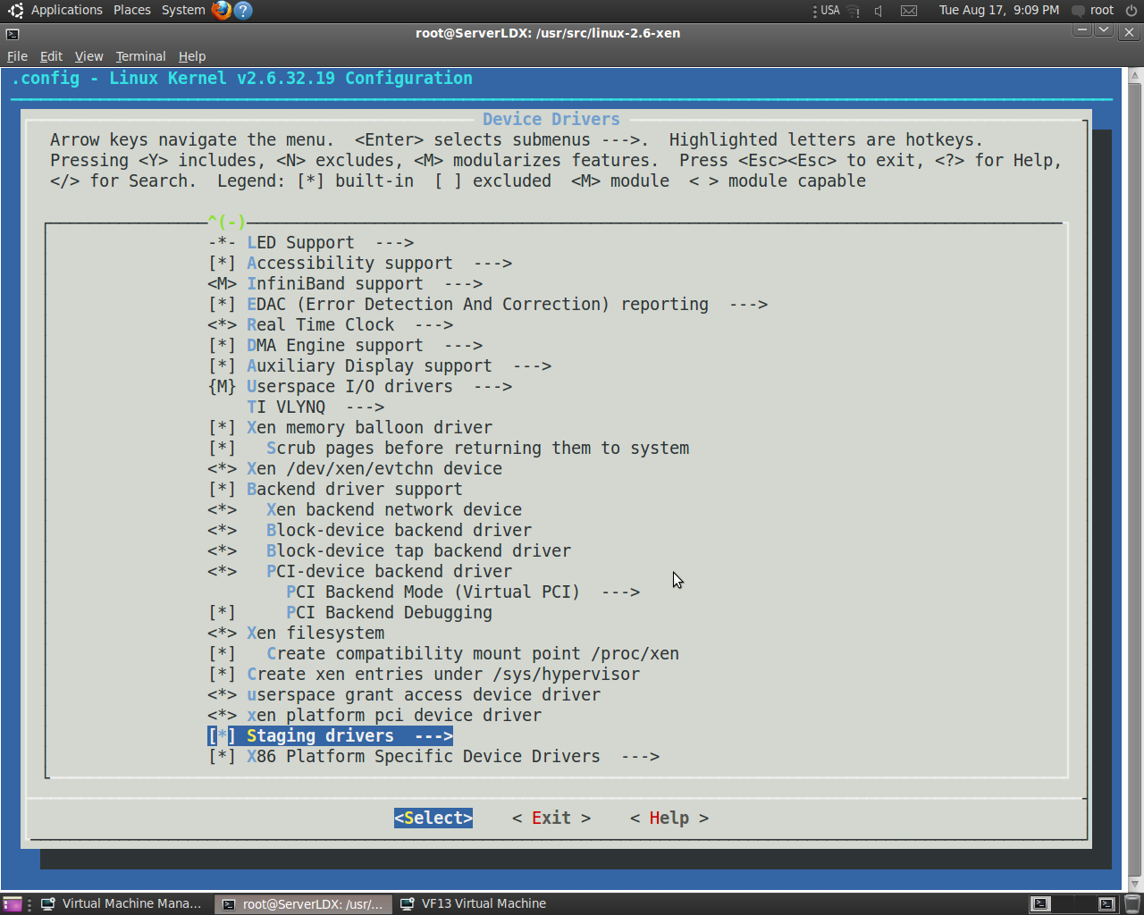

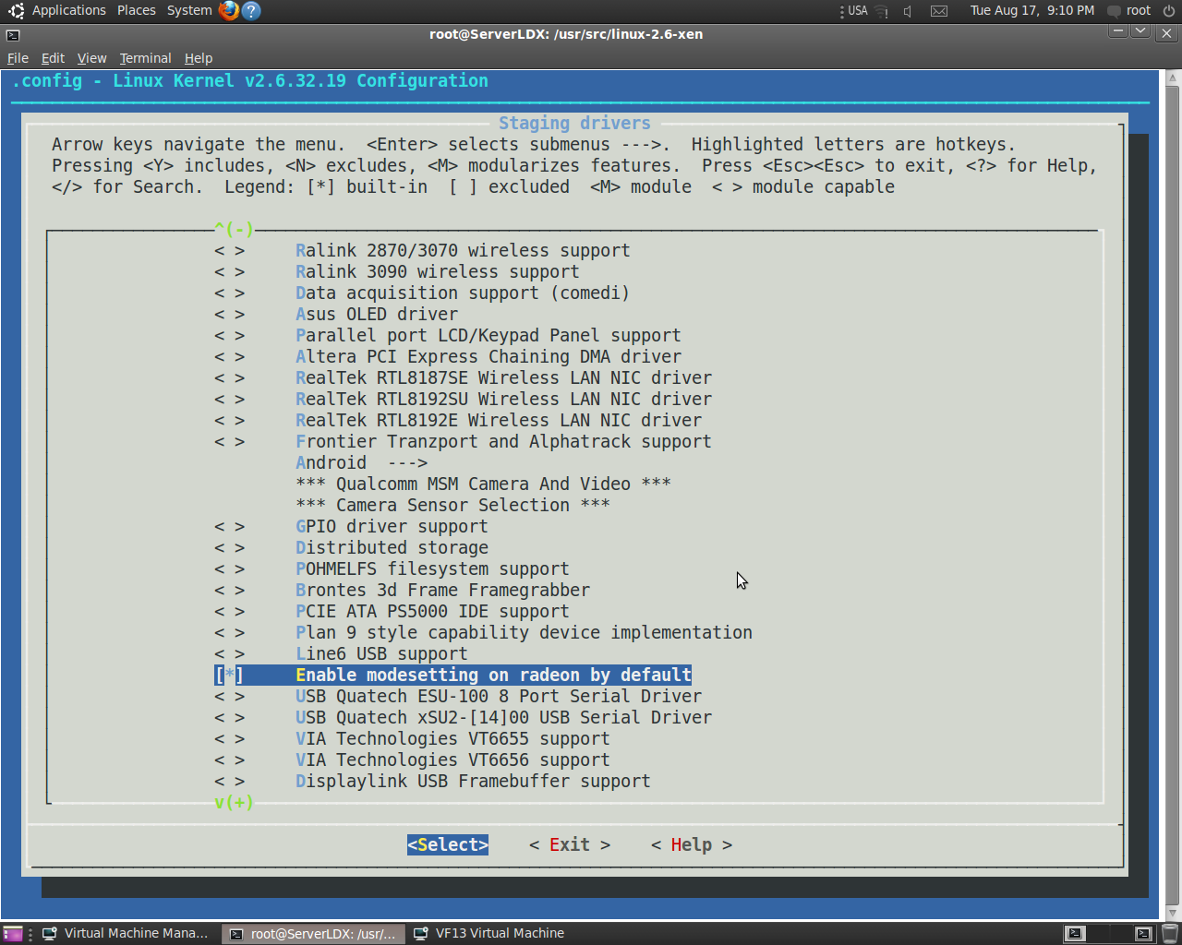

Build kernel in Debian way. Config [may be viewed here](http://pastebin.com/Qf304Nt3)  
  
export CONCURRENCY_LEVEL=(number_of_cores) +1  
make-kpkg clean  
fakeroot make-kpkg --initrd --append-to-version=-xen kernel-image kernel-headers  
dpkg -i ../linux-image-2.6.32.19-xen_2.6.32.19-xen-10.00.Custom_amd64.deb  
update-initramfs -c -k 2.6.32.19-xen  
  
Set up Xen 4.0.1-rc6   
  
# cd /usr/src  
# hg clone http://xenbits.xensource.com/staging/xen-4.0-testing.hg  
# cd xen-4.0-testing.hg  
# make xen  
# make tools  
# make install-xen  
# make install-tools PYTHON_PREFIX_ARG=  
  
Set up xend,xendomains to run as services

update-rc.d xend defaults 20 21  
update-rc.d xendomains defaults 21 20

Reboot in Xen with grub entry  
  
menuentry "Xen 4.0.1-rc6 / Ubuntu 10.04 kernel 2.6.32.19" {  
insmod ext2  
set root='(hd0,9)'  
multiboot (hd0,9)/boot/xen.gz dummy=dummy  
module (hd0,9)/boot/vmlinuz-2.6.32.19-xen dummy=dummy root=/dev/sdb5 ro console=tty0  
module (hd1,5)/boot/initrd.img-2.6.32.19-xen  
}  
  
Verify environment  
  
root@ServerLDX:~# xm info  
host : ServerLDX  
release : 2.6.32.19-xen  
version : #3 SMP Tue Aug 17 17:45:48 MSD 2010  
machine : x86_64  
nr_cpus : 4  
nr_nodes : 1  
cores_per_socket : 4  
threads_per_core : 1  
cpu_mhz : 2833  
hw_caps : bfebfbff:20100800:00000000:00000940:0408e3fd:00000000:00000001:00000000  
virt_caps : hvm  
total_memory : 8190  
free_memory : 1024  
node_to_cpu : node0:0-3  
node_to_memory : node0:1024  
node_to_dma32_mem : node0:1024  
max_node_id : 0  
xen_major : 4  
xen_minor : 0  
xen_extra : .1-rc6  
xen_caps : xen-3.0-x86_64 xen-3.0-x86_32p hvm-3.0-x86_32 hvm-3.0-x86_32p hvm-3.0-x86_64  
xen_scheduler : credit  
xen_pagesize : 4096  
platform_params : virt_start=0xffff800000000000  
xen_changeset : Fri Aug 13 15:06:24 2010 +0100 21321:5e8df2d2ef6f  
xen_commandline : dummy=dummy  
cc_compiler : gcc version 4.4.3 (Ubuntu 4.4.3-4ubuntu5)  
cc_compile_by : root  
cc_compile_domain :  
cc_compile_date : Sun Aug 15 18:49:37 MSD 2010  
xend_config_format : 4  
  
root@ServerLDX:~# brctl show  
bridge name bridge id STP enabled interfaces  
eth0 8000.90e6ba2d11eb no peth0  
virbr0 8000.000000000000 yes  
  
Dmesg fragment  
  
[drm] radeon: Initializing kernel modesetting.  
[drm] register mmio base: 0xFE8E0000  
[drm] register mmio size: 65536  
ATOM BIOS: 11X  
[drm] Clocks initialized !  
mtrr: type mismatch for d0000000,10000000 old: write-back new: write-combining  
[drm] Detected VRAM RAM=256M, BAR=256M  
[drm] RAM width 128bits DDR  
[TTM] Zone kernel: Available graphics memory: 4074556 kiB.  
[TTM] Zone dma32: Available graphics memory: 2097152 kiB.  
[drm] radeon: 256M of VRAM memory ready  
[drm] radeon: 512M of GTT memory ready.  
[drm] Loading RV730 CP Microcode  
platform radeon_cp.0: firmware: requesting radeon/RV730_pfp.bin  
platform radeon_cp.0: firmware: requesting radeon/RV730_me.bin  
[drm] GART: num cpu pages 131072, num gpu pages 131072  
[drm] ring test succeeded in 1 usecs  
[drm] radeon: ib pool ready.  
[drm] ib test succeeded in 0 usecs  
[drm] Radeon Display Connectors  
[drm] Connector 0:  
[drm] HDMI-A  
[drm] DDC: 0x7f10 0x7f10 0x7f14 0x7f14 0x7f18 0x7f18 0x7f1c 0x7f1c  
[drm] Encoders:  
[drm] DFP2: INTERNAL_UNIPHY1  
[drm] Connector 1:  
[drm] VGA  
[drm] DDC: 0x7e20 0x7e20 0x7e24 0x7e24 0x7e28 0x7e28 0x7e2c 0x7e2c  
[drm] Encoders:  
[drm] CRT2: INTERNAL_KLDSCP_DAC2  
[drm] Connector 2:  
[drm] DVI-I  
[drm] DDC: 0x7e40 0x7e40 0x7e44 0x7e44 0x7e48 0x7e48 0x7e4c 0x7e4c  
[drm] Encoders:  
[drm] CRT1: INTERNAL_KLDSCP_DAC1  
[drm] DFP1: INTERNAL_UNIPHY  
[drm] fb mappable at 0xD0141000  
[drm] vram apper at 0xD0000000  
[drm] size 5242880  
[drm] fb depth is 24  
[drm] pitch is 5120  
executing set pll  
executing set crtc timing  
[drm] TV-11: set mode 1280x1024 19  
Console: switching to colour frame buffer device 160x64  
fb0: radeondrmfb frame buffer device  
registered panic notifier  
[drm] Initialized radeon 2.0.0 20080528 for 0000:01:00.0 on minor 0  
  
Setup Libvirt 0.8.2 per [2] and test virt-install F13 for instance.

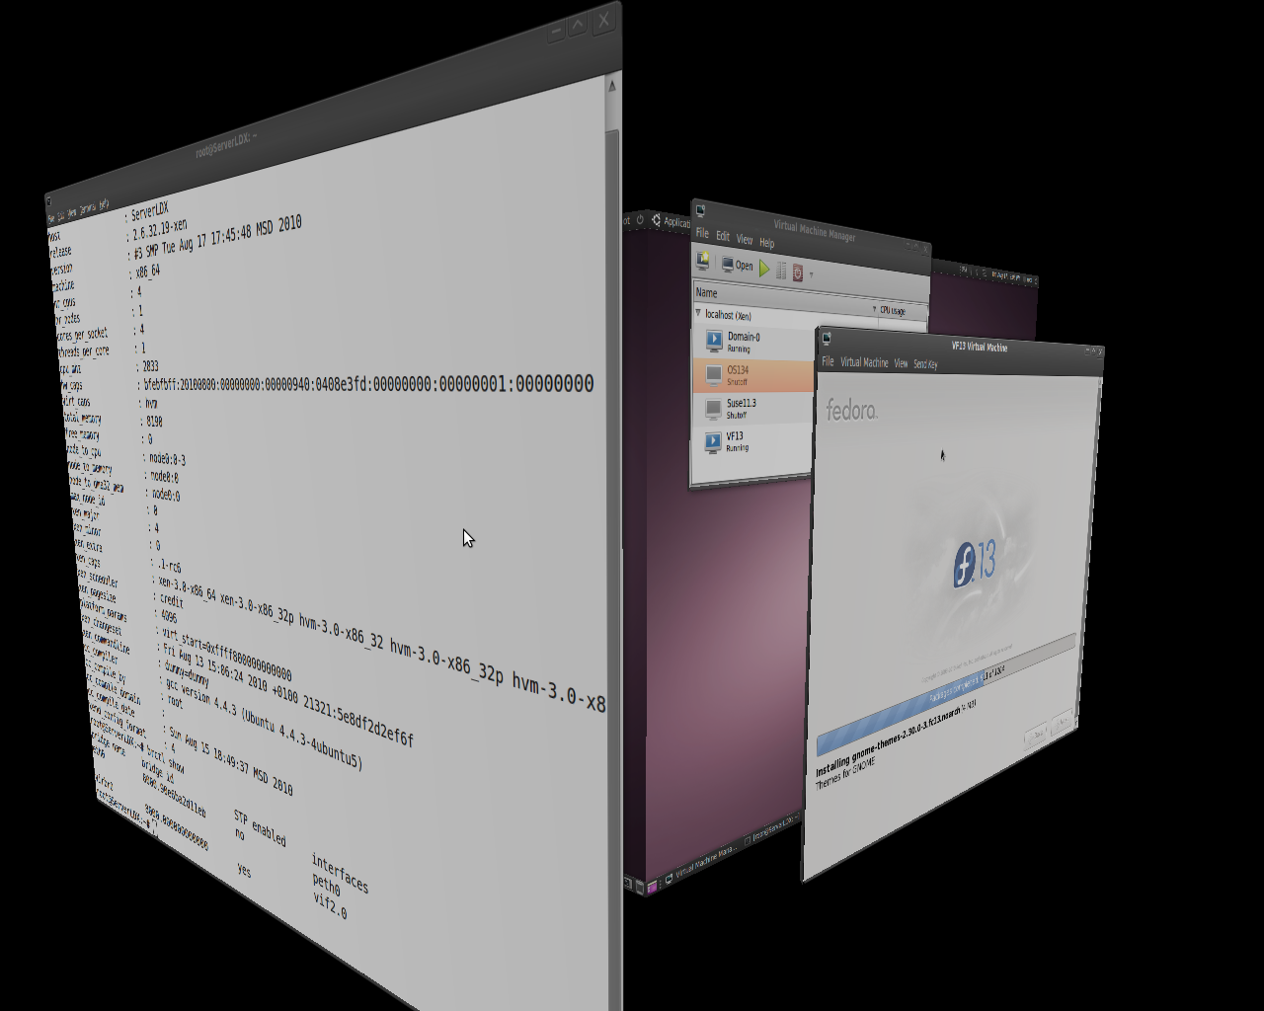

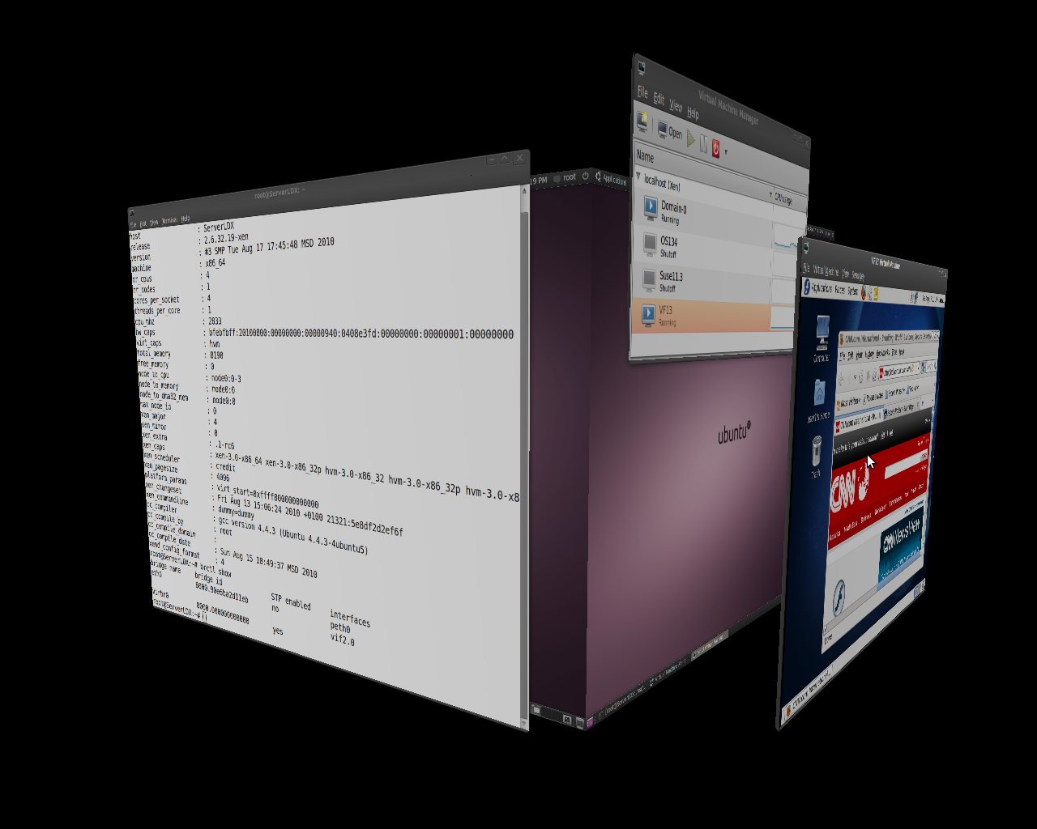

OSOL 134 running as PV guest

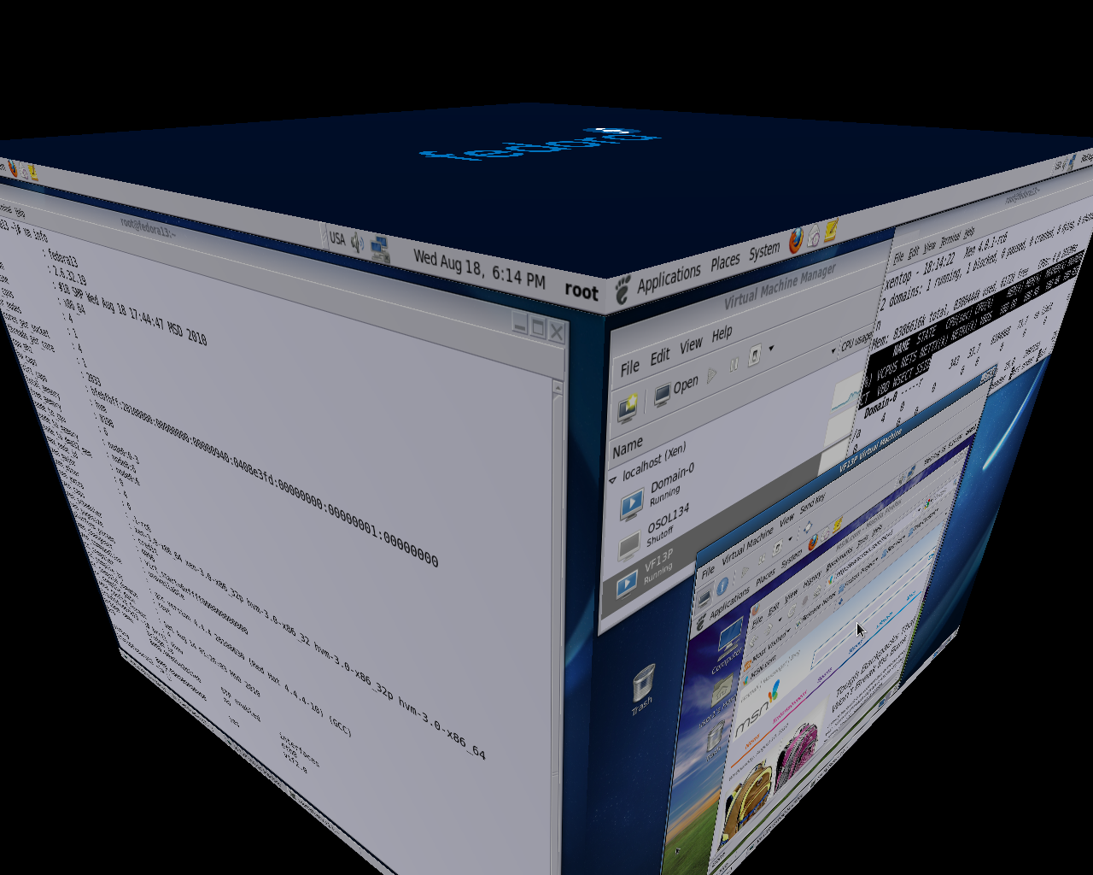

Snapshots for Fedora 13

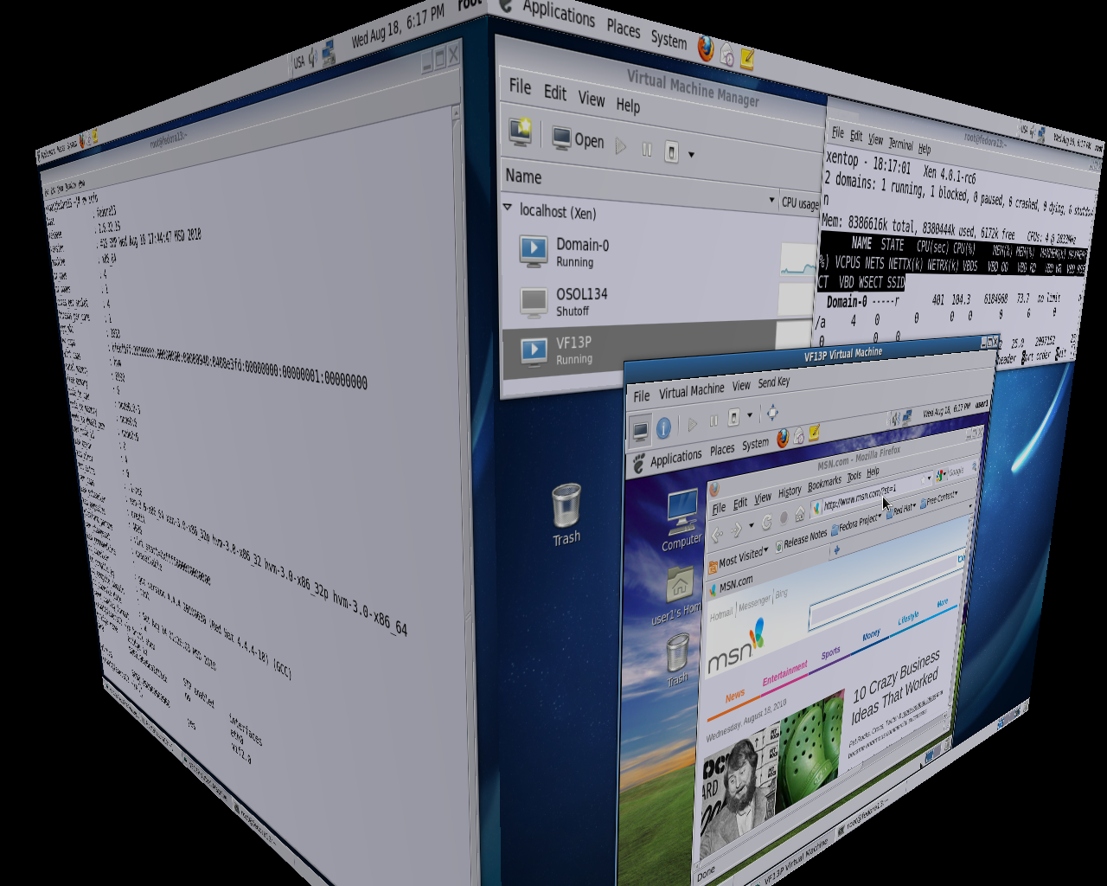

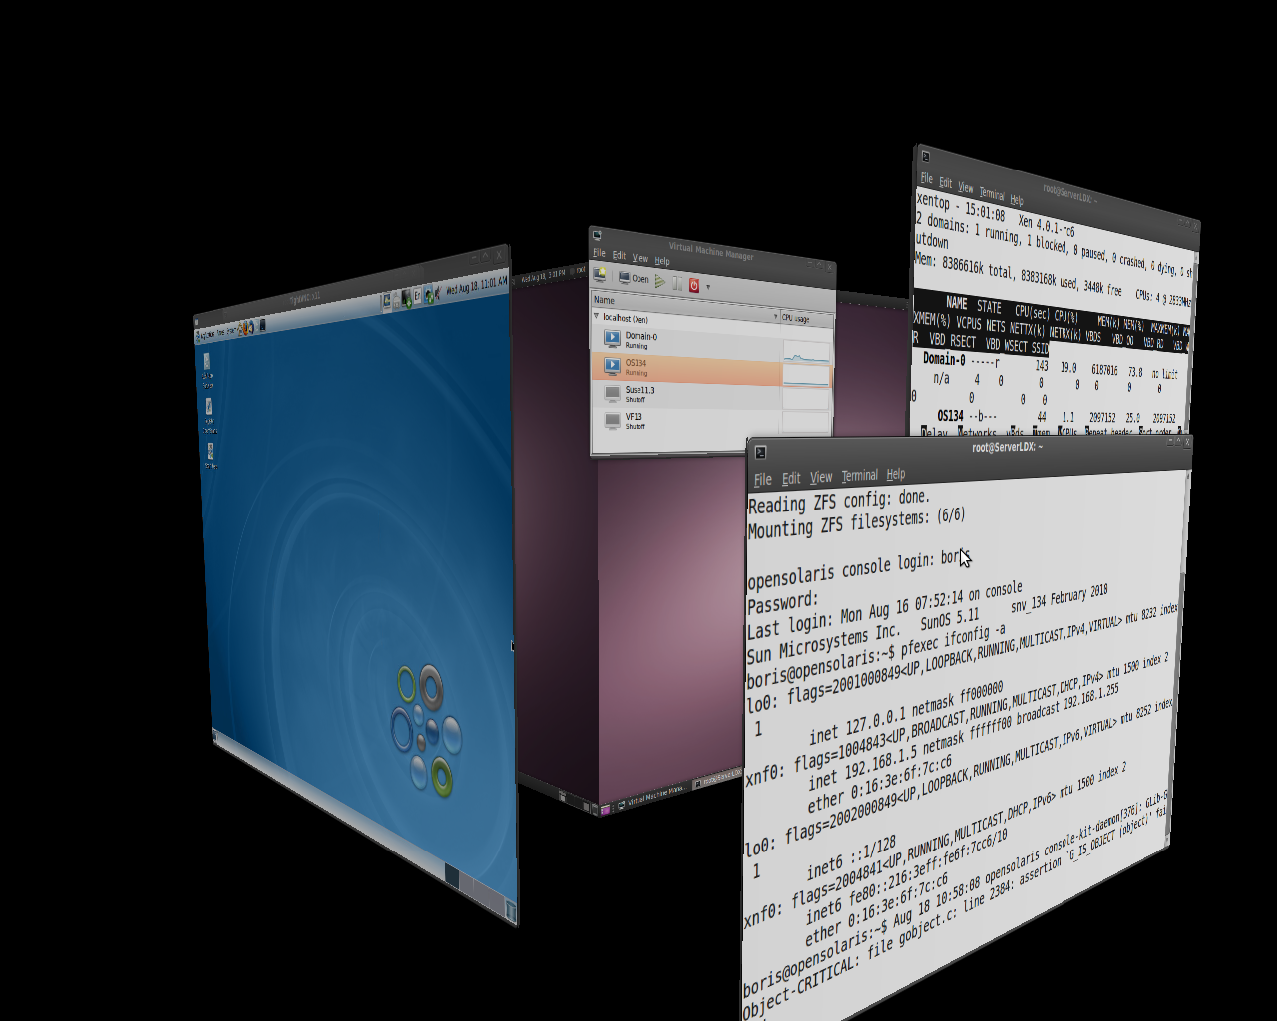

References   
View http://wiki.xen.org/xenwiki/Xen4.0  
Tutorials to install Xen 4.0  
1. Xen 4.0 on Ubuntu 10.04: http://bderzhavets.wordpress.com/2010/04/24/set-up-ubuntu-10-04-server-pv-domu-at-xen-4-0-dom0-pvops-2-6-32-10-kernel-dom0-on-top-of-ubuntu-10-04-server/  
2. Xen 4.0 + virt-manager on Ubuntu 10.04: http://bderzhavets.wordpress.com/2010/06/02/setup-libvirt-0-8-0-xen-4-0-on-top-of-ubuntu-10-04-server-via-daniel-baumann-virtualization-ppa/  
3.http://wiki.xensource.com/xenwiki/XenPVOPSDRM